
University of Engineering and Technology, Mardan

Week 1 Task Report:

Career Launchpad Phase II
By: Maham Arif
Reg.no: 24MDBCS549
Section: ‘A’
Batch: 7
To: Sir Zaheen
Date: 8/7/2026
Department of Computer Science ,UET Mardan

Task 1:
Introduction
This task is part of Career Launchpad Phase 2, Week 1, under the Data Analysis & Visualization domain. The objective was to perform a complete workflow of data import, cleaning, preprocessing, analysis, and visualization on the Breast Cancer Wisconsin dataset, and present the findings in a structured GitHub repository.

Data Cleaning & Preprocessing
We began by importing the dataset into a Pandas DataFrame.
- Dataset Info & Structure: Checked column types and dataset dimensions.
- Missing Values: Verified if any columns contained null values.
- Duplicates: Removed duplicate rows to ensure data integrity.
- Filled missing numeric values with column means.
- Index Reset: Reset the index after cleaning for consistency.

Exploratory Data Analysis (EDA)
We performed a detailed analysis to uncover hidden insights:
- Class Distribution: The dataset showed more benign cases (~350) compared to malignant (~200), indicating slight imbalance. (Screenshot 1: Bar chart of diagnosis distribution)
- Statistical Summary: Descriptive statistics revealed ranges, means, and variability of features.
- Feature Variability: Standard deviation analysis highlighted which features varied most across samples.
- Group Statistics: Compared malignant vs benign averages, malignant tumors had significantly larger radius, perimeter, and area. (Screenshot 2: Table of group means)
- Correlation Analysis: A heatmap revealed strong correlations among features like radius, perimeter, and area, and their strong link to diagnosis.
Data Visualization:
Visualizations were used to highlight key findings:
- Diagnosis Distribution: Bar chart showed imbalance between malignant and benign cases. (Screenshot 1)
- Feature Distribution: Histogram of `radius_mean` showed right-skewed distribution, with most values between 10–15. (Screenshot 2)

Key Insights:
- The dataset is clean, with no major missing values.
- Malignant tumors generally have larger measurements (radius, perimeter, area).
- Certain features are highly correlated, which may require dimensionality reduction in modeling.
- The dataset is suitable for predictive modeling tasks such as classification.

Output Screenshots:
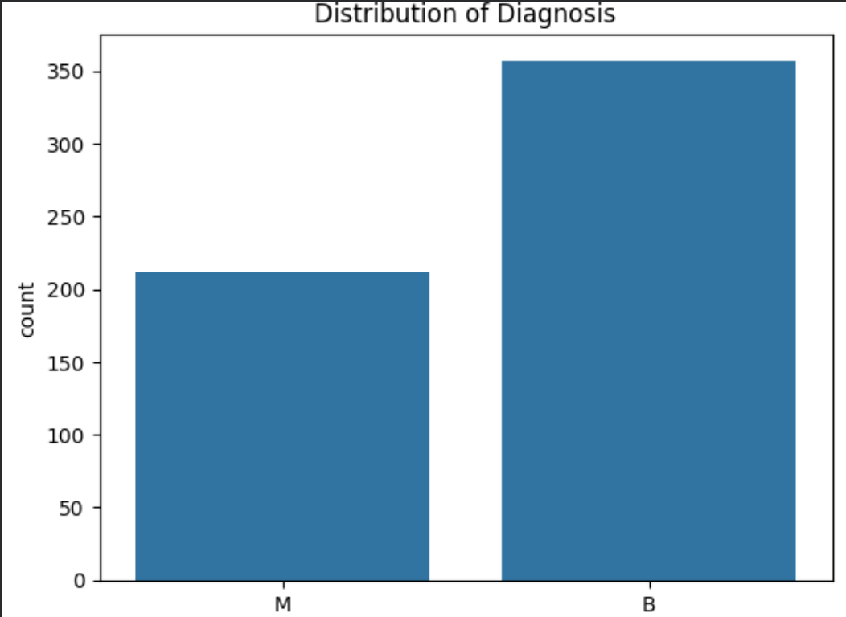

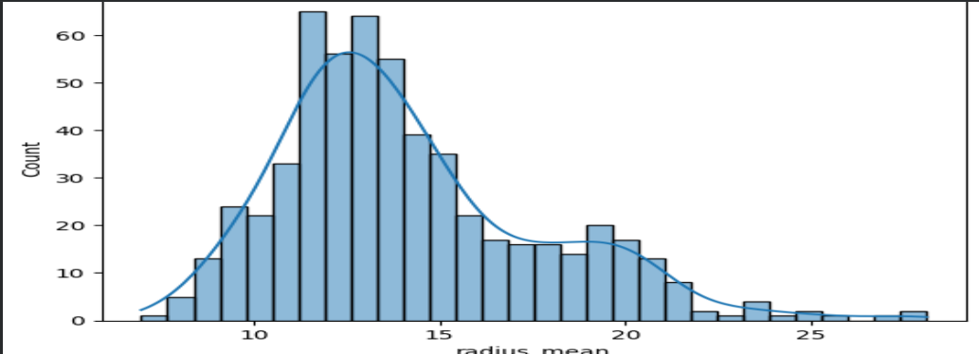

Task 2:

Introduction:
As part of Week 1, Task 2 focused on spreadsheet basics using the Titanic data set.the Titanic data set was analyzed using spreadsheet tools. This task emphasized the use of COUNT, SUM, and AVERAGE formulas to uncover patterns in passenger demographics and survival outcomes.

Data Import:
- Data set imported into Excel and Google Sheets from the provided CSV link.
- In Excel, Power Query was used to clean and prepare the dataset.
- In Google Sheets, formulas were applied directly to the dataset.

Analysis with Functions:
- COUNT functions helped quantify survival counts, gender distribution, missing ages, and unique ticket classes
- SUM functions were used to calculate totals, such as the overall fares paid by passengers.
- AVERAGE functions provided meaningful measures like the average passenger age and average fare. Together, these formulas highlighted that survival rates were higher among females and first-class passengers, while missing values in the Age column were easily identified and quantified.

Key Insights:
- Majority of passengers were male.
- Survival rate was higher among females and first-class passengers.
- Age column had missing values, identified using COUNTBLANK.

Conclusion:
In Task 1, the Breast Cancer data set was cleaned and analyzed in Python (Colab). Missing values and duplicates were handled, descriptive statistics were generated, and visualizations like diagnosis distribution and feature histograms highlighted key differences between malignant and benign cases.
In Task 2, the Titanic data set was explored in Excel and Google Sheets using formulas such as COUNT, SUM, and AVERAGE. These revealed passenger demographics, survival counts, missing ages, and average fares and ages, showing higher survival among females and first-class passengers.

